Project Design Phase-II
Data Flow Diagram & User Stories
Date | 24-09-2026
Team ID | SWTID-2026-2008
Project Name | BlogNest – ContentGen Backend
Maximum Marks | 4 Marks
Data Flow Diagram (DFD)
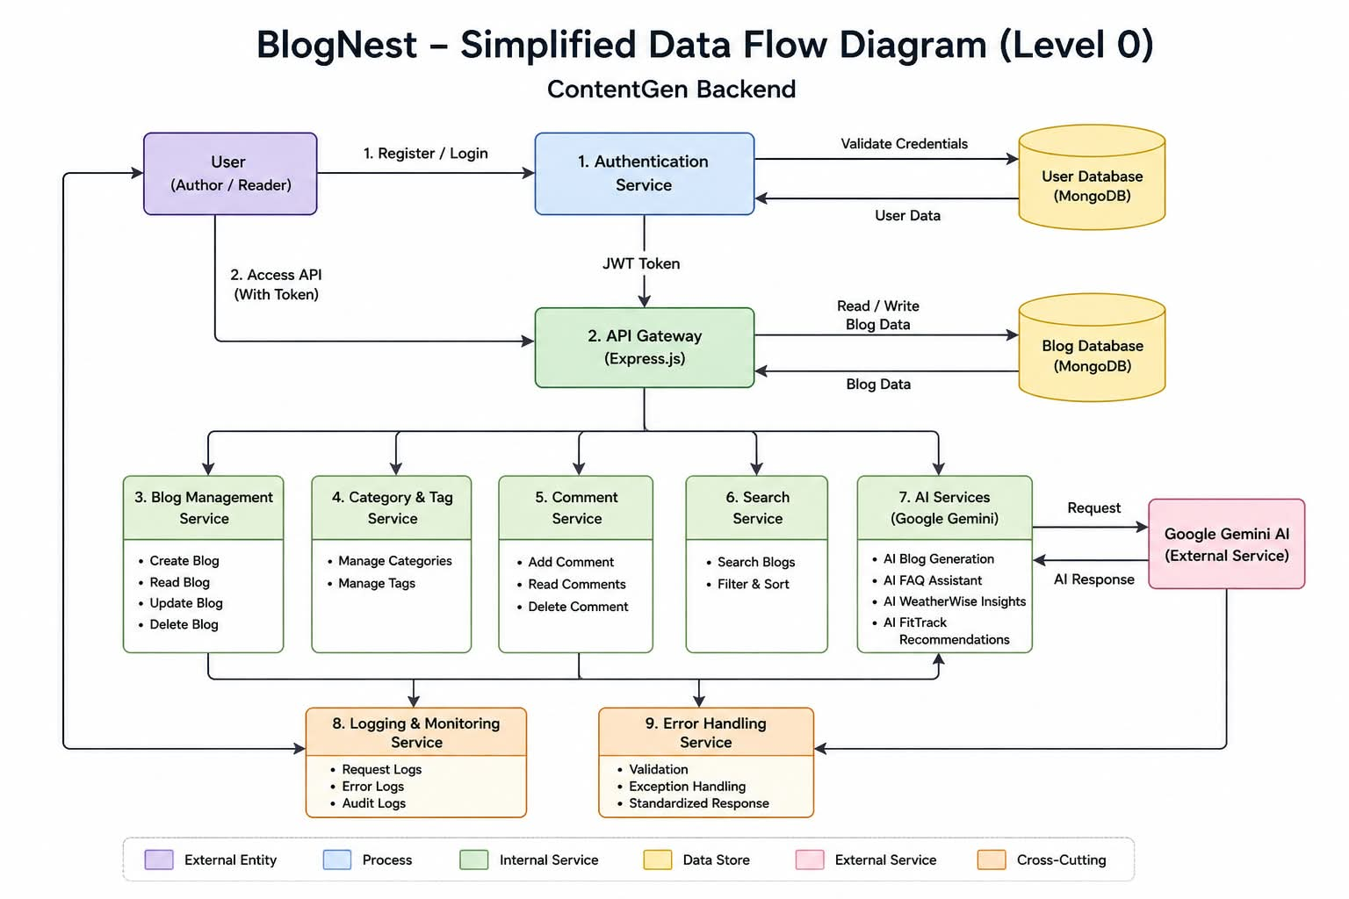
The DFD represents how information moves through the BlogNest ContentGen backend. Users and administrators send requests through the REST API. Authentication and authorization are handled using JWT and role-based access control. Controllers and services process requests, interact with MongoDB through Mongoose, and connect to Google Gemini AI for intelligent content features. Responses, generated content and error messages are returned to the requesting client.

User Stories
The following user stories are prepared for the BlogNest ContentGen backend. USN-9 is the final user story.
User Type | Functional Requirement (Epic) | User Story Number | User Story / Task | Acceptance Criteria | Priority | Release
Reader / Author / Editor / Admin | Registration | USN-1 | As a user, I can register for BlogNest by entering my name, email, password and phone number. | I can submit valid name, email, password and phone number; required fields are validated; password is securely hashed; account is created. | High | Sprint-1
Reader / Author / Editor / Admin | Login | USN-2 | As a registered user, I can log in using my email and password. | Valid credentials authenticate the user and a JWT token is generated; invalid credentials return a clear error. | High | Sprint-1
Reader / Author / Editor / Admin | Profile | USN-3 | As a user, I can view and update my profile information, including name, email and phone number. | Authenticated users can view their profile and update allowed fields after validation. | Medium | Sprint-1
Author / Editor | Blog Management | USN-4 | As an Author or Editor, I can create and manage blog posts with title, content, category and tags. | Authorized users can create, update and delete their own/allowed blogs; data is validated and stored in MongoDB. | High | Sprint-1
Reader / Author / Editor / Admin | Blog Viewing | USN-5 | As a user, I can view published blog posts and search for blogs using keywords. | Published blogs are returned correctly and search results match the entered keyword or relevant blog data. | High | Sprint-2
Author / Editor / Admin | Comments | USN-6 | As a user, I can add comments to blog posts, and authorized users can manage or moderate comments. | Authenticated users can add valid comments; authorized roles can manage inappropriate or unwanted comments. | Medium | Sprint-2
Admin / Editor | Categories & Tags | USN-7 | As an Admin or Editor, I can create, update and manage categories and tags for blogs. | Only authorized roles can manage categories/tags and changes are stored correctly in MongoDB. | Medium | Sprint-2
Admin | Security & Administration | USN-8 | As an Admin, I can manage users and roles securely and ensure that authentication, authorization and API security rules are enforced. | Admin-only operations require a valid JWT and Admin role; passwords are hashed with bcrypt.js; input is validated/sanitized; rate limiting and structured error handling are applied; unauthorized requests are rejected. | High | Sprint-2
BlogNest – ContentGen Backend | Data Flow Diagram & User Stories

